I had always wanted to visit the Spinal Unit, University of Hong Kong ever since I had read of the Hong Kong operation for Tuberculosis as an orthopaedic trainee. This Unit was at the forefront of spinal research and teaching since the 1950’s and has continued in the same vein being the first to publish its results on the Magnetically Controlled Growing Rods in 2012.
The unit is headed by Professor Cheung assisted by Prof Wong and their colleagues who were very welcoming and caring. It is based on two sites, the Queen Mary Hospital, Pokfulam Road and the Duchess of Kent Hospital, Sandy Bay. Both sites have activities on all days.
I chose to embark on my fellowship between two posts which fell in October 2019 and at the height of the Hong Kong protests. I was advised that the protests were largely at the weekends and the rest of the week was reasonably safe which I found to be entirely correct. I chose to proceed knowing the this was a great opportunity not to be missed. As a city Hong Kong is expensive so I chose an AirBnB which was suitable to both locations, quite central and reasonable as well.
I spent most of my clinical time in the Duchess of Kent Children’s Hospital as I have an interest in spinal deformity. I wanted to gain a deeper understanding into the Hong Kong approach to scoliosis management based entirely on their previously published work. I wanted to attend more clinics and also gain appreciation of the non-operative aspect including the physiotherapy and bracing aspects too. I also intended to compare our system in the NHS with the Hong Kong system and bring back any new aspects that would be useful to our patients and disseminate this information.
The scoliosis clinics are fed by the scoliosis screening by the school health service, which was set up by this unit, providing a steady supply of presentations. Depending on the age of the child and curve magnitude, if a non-operative decision is appropriate, a referral is made to the orthotics department. Bracing is an art in itself and the spinal unit is at the forefront of non-operative management (Fig 1). Here the braces have a built-in heat sensor to ascertain compliance and patients need a read-out from the sensor prior to attending clinics. Compliance is a major issue in the NHS and has been shown to effectively control the curve magnitude and prevent the need for surgical intervention. I intend to investigate ways and means of increasing compliance in my unit to reduce operative intervention. Physiotherapy plays a major role in controlling curves with the Schroth technique which is proving successful in many centres around the world. This is another area where we can increase our resources to reduce the need for surgery.
The other days were a mix of theatre and clinics where I was involved heavily. I noted some interesting areas of research where I got involved and these are close to completion.
The Grand Rounds are held on Wednesday at the Duchess of Kent Hospital. We discussed all in-patients under our care. This was a multidisciplinary ward round with physiotherapy, occupational therapy and social worker input.
Fridays are pre-operative planning days for the next week and involve presentations and lengthy discussions of all procedures with the whole team being involved at their own level. There is a video link with the Shenzhen Hospital in mainland China discussing their cases as well.
On Saturdays we would attend a pan-Hong Kong meet with interesting cases and complications (almost like a Regional Morbidity and Mortality meeting). There was ample discussion with audience involvement of which I played my part.
The Trauma and Orthopaedic Department at Queen Mary Hospital has a tradition of inviting Professors from across the globe dating back from 1968 (Fig 2). They present a series of lectures over 4 days which includes teaching and leading the Grand Round. During my visit the MB Lee Visiting Professor was Prof. Matsuyama from Japan(Fig 3). He is also the current President of the Japanese Society for Spine Surgery and Related Research (JSSR). He presented a series of very informative lectures on complex Adult Spinal Deformity procedures and how to optimise the patients and reduce mortality from his experience.
We visited Shenzhen Hospital (Fig 4) as a team where he presented a talk after the rounds. A visa was required which I managed to obtain in 2 days. I have noted the design of the modified wheelchair to use with Halo Traction in patients with severe scoliosis who undergo a period of traction to reduce the curve prior to definitive fusion and intend to use those in our unit after appropriate permission.
Shenzhen Hospital is a 2000 bed unit with pharmacy robots delivering medication to the wards. I was impressed by the scale of the hospital and how advanced it was in delivering patient care.
I had noted that the Hong Kong Orthopaedic Association Annual conference was at the end of my fellowship and was able to submit abstracts for the same and present four podium presentations based on my work in St. George’s Hospital on Vertebral Body Tethering and Scoliosis. This was very well received, and I received a personal invitation from Prof. Matsuyama to present my experience at the JSSR meet in Nagoya, Japan.
Overall this has been an amazing experience for me both professionally and personally. I have gained experience which will help not only my own patients but hopefully all the patients of my unit and all of UK. I have formed ties that will be invaluable to not only my own career but to future trainees who may wish to visit the unit.
Hong Kong as a city is a wonderful mix of Great Britain and China and I enjoyed every moment thoroughly and recommend it for a visit. The food was exciting and the buzz in the city was memorable.
I am very thankful to the British Orthopaedic Association and PGO for granting this wonderful opportunity to gain so much from this travelling fellowship and hope to use all the experience and knowledge to benefit of our patients in the NHS every day.

Fig 1. Bracing workshop
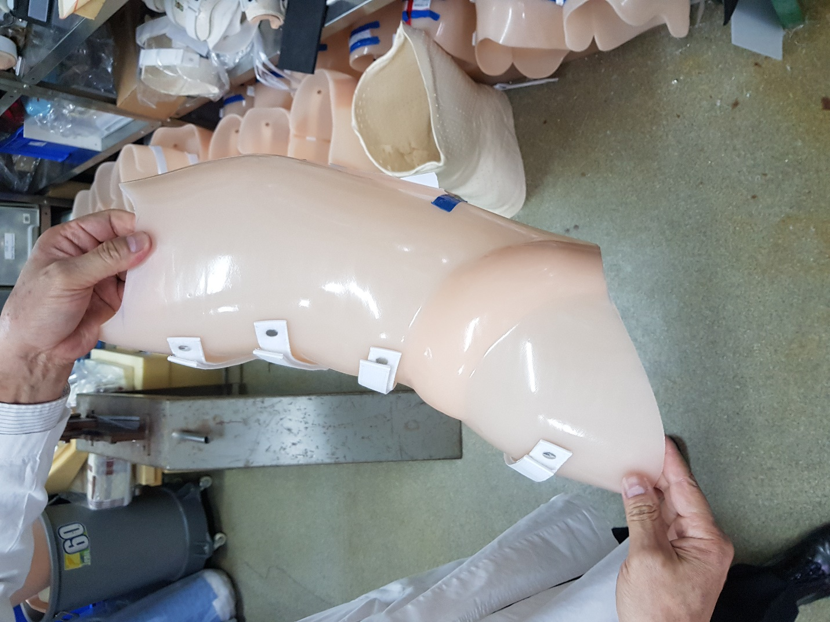

Fig 2. Visiting Professors Wall

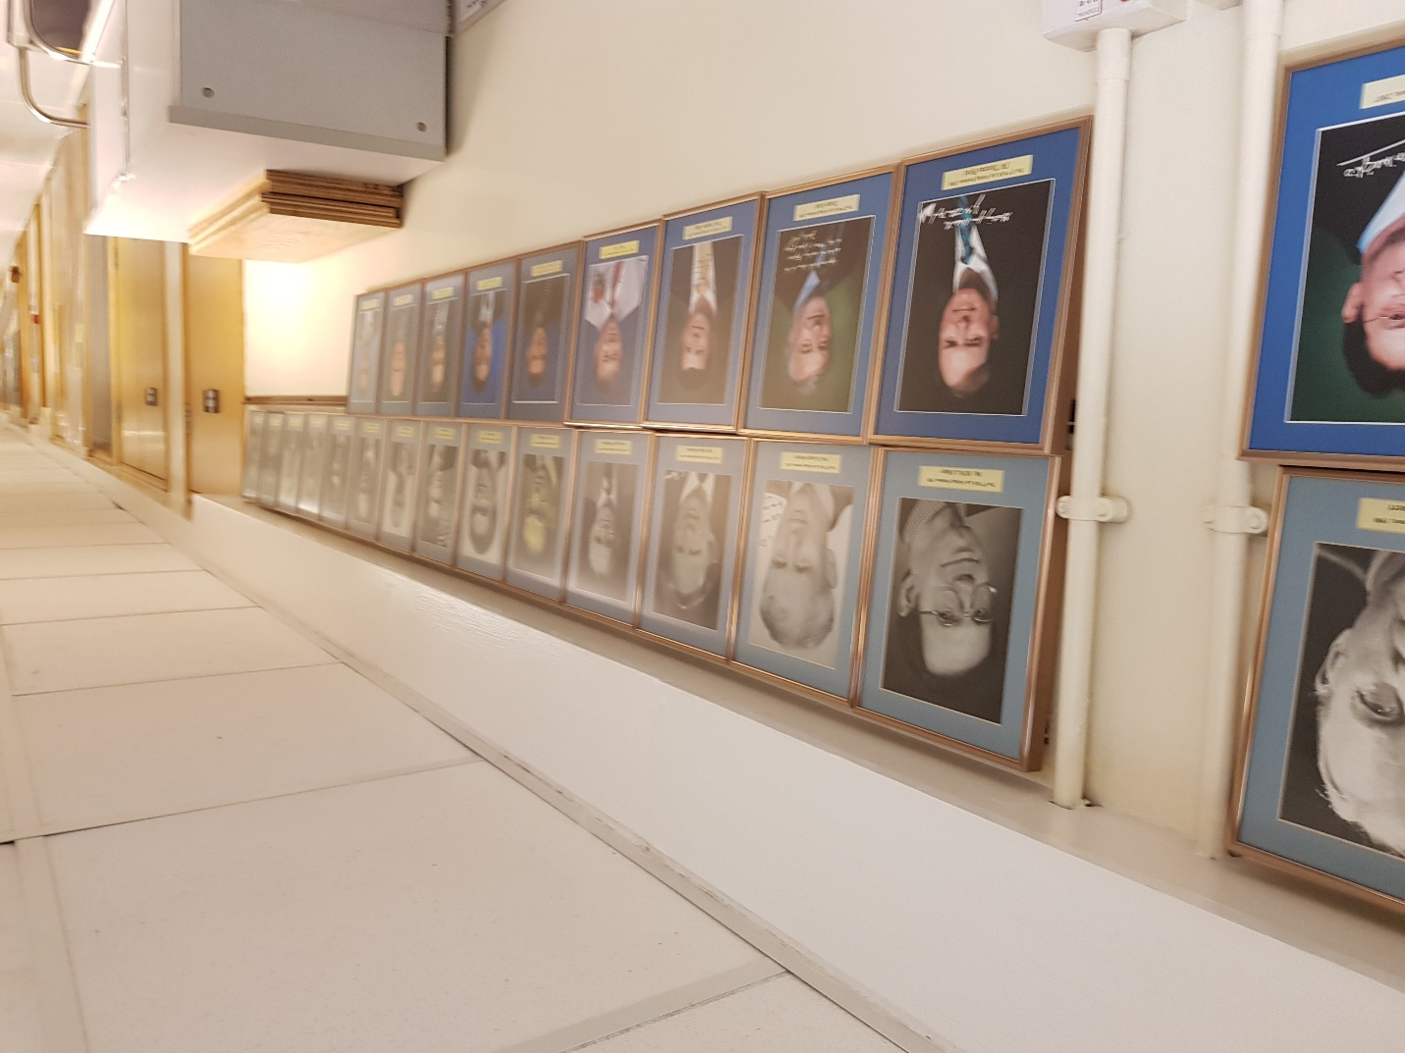

Fig. 3 Prof Cheung, Prof Matsuyama and myself on the balcony of the dining hall of the University of Hong Kong.

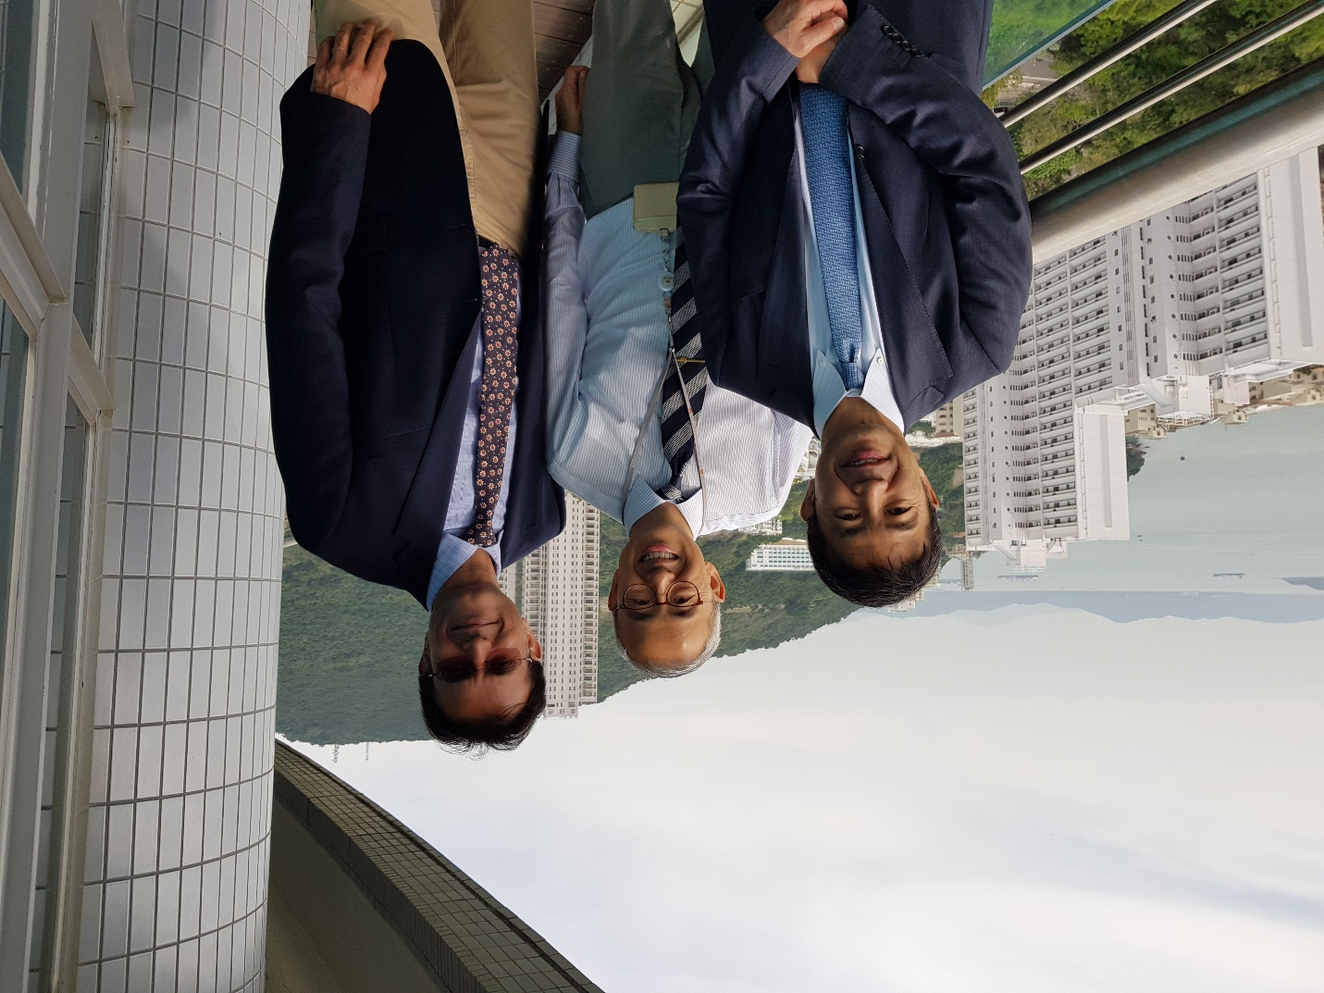

Fig 4. A model of Shenzhen Hospital
