BOA Travelling Fellowship Report for James Shelton: The Children’s Surgical Centre Phnom Penh August 2019 – February 2020

Executive Summary:
During the period of August 2019 to February 2020 I worked at The Children’s Surgical Centre in Phnom Penh Cambodia. I undertook this fellowship along with my wife, Sara, who is also a paediatric orthopaedic surgeon and my son who was two. The clinical experience and non technical skills learned during this placement were phenomenal and I would highly recommend this kind of experience to anyone. I found myself in a limb reconstruction role of complex neglected trauma whilst Sara mostly dealt with the congenital paediatric population. Whilst at CSC we started an orthopaedic curriculum roughly mapped to the UK curriculum in order to give back some knowledge to the institution as described below, we ran basic fracture management courses for the residents and organised a number of case conferences with Bristol to discuss challenging cases with. I believe that we were at the best possible place in our careers to do this sort of placement as just post exam we are probably at the most knowledgeable about general orthopaedics prior to subspecialisation and competent to perform the majority of operations encountered. I hope to make visits to CSC a continuing part of my practice life long.

Report:

I started on my path to becoming an orthopaedic surgeon many years ago as an enthusiastic 4th year medical student. I travelled to Malawi on my elective and was hooked on both orthopaedics and the idea of working in the developing world.

In late 2018 and early 2019 my wife and I decided to do the unthinkable and sit the FRCS Tr & Orth together whilst trying to wrangle our toddler and manage the healthcare needs of my mothers diagnosis of cholangiocarinoma and my father-in-law’s diagnosis of highly aggressive prostate cancer. I don’t share this with you for sympathy, I just want to illustrate that there are often significant challenges to working abroad. You can always find reasons not to do it if it is something you want to do, find a way – our trip was made possible to a large extent by the generosity of the BOA granting us a travelling fellowship award.

I had heard Jim Gollogly the CEO of The Children’s Surgical Centre (CSC) Phnom Penh and Fergal Monsell a consultant in Bristol who has visited CSC previously speak a number of times at various conferences and felt this could be the location we have been looking for.

Delving further into the history of Cambodia makes for tragic reading, within living memory 1975 – 1979 marked some of the darkest days in modern history under the Khmer Rouge. An estimated 3 million people killed – almost 25% of a nation gone in 4 years. The victims were largely educated or those with glasses mistaken as a sign of intellectualism and often the whole family would be killed. By the end of the regime there were six doctors for a nation. Adding to the human cost of a conflict long resolved is the number of landmines and unexploded ordnance left behind that occasionally blows up unsuspecting farmers although motorcycle accidents are by far the most prevalent mechanism of injury!

We decided as a couple that the time was right and we should try and organise this whilst continuously wavering over the health of our parents. Up until this point in our careers we had a small voice in the back of our heads – if only we knew a bit more, if only we could do a few more procedures we could be of so much more use. Well immediately post exam I suspect is the zenith of your general orthopaedic knowledge before you become increasingly subspecialised and once fellowships and consultant jobs come along it only becomes harder to find six months for this kind of adventure!

Our major issue of concern when moving to a developing country was our two year old, Harry – most of our friends and family thought we were completely mad to consider taking a toddler with us. In reality it turns out they have kids in Cambodia too but as all parents know it does massively increase the amount of forethought and planning on such an expedition. We chose to go for a holiday with our son in April 2019, spending a week in Phnom Penh exploring the city– this was well worth it, we sorted out accommodation, a pre-school for Harry and got a feel for the city. It adds to the cost it puts your mind at ease as a parent.

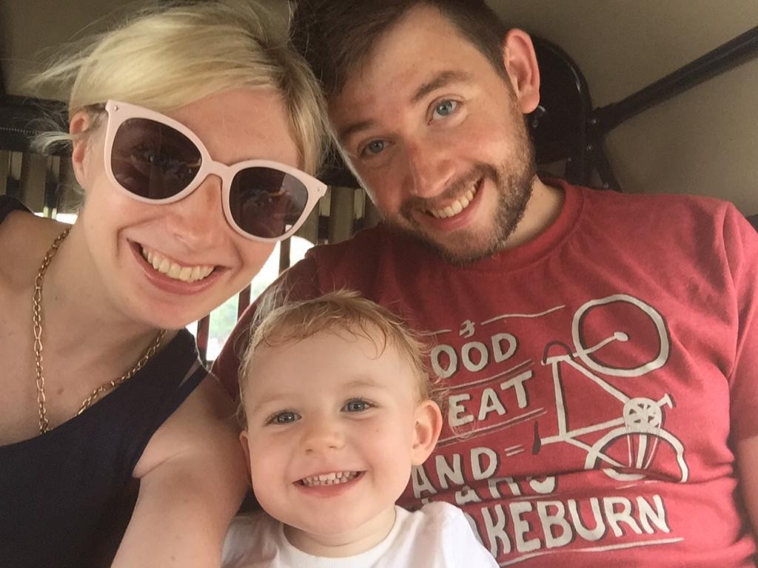

At the end of July 2020 flights booked, accommodation and pre-school sorted and a piece of paper from the hospital administrator which he assured us would get us a visa and we were ready to go! We took a week off work to emigrate as there is always a few things to get sorted in any move, the most important for us was employing a nanny; pre-school was 8am – 3pm and our work 8am - 5pm plus commute so we needed someone to do the nursery drop-off and pick-up. Our advice is to get on the Facebook parent groups – there is always expats coming and going who want to pass on their faithful nanny to the next family as we did for ours on our return.

So Harry went to pre-school and we went to work. Jim had warned us that due to the differing training programs we as post FRCS UK trainees would be full of knowledge and lacking in confidence and the Khmer surgeons full of confidence but lacking in knowledge of basic principles. I think this assessment is fair, not for any reason other than the UK’s long and rigorous training program. The local surgeons at CSC are great but they graduate medical school, are enrolled in a 3 year residency and if exceptional are offered a 1 year fellowship in France (most of the surgeons at CSC have done this) then you are an independent attending. I am older than both the attending orthopods at CSC and I have gone straight through our training program.

My first case at CSC was a knee fusion for a previous septic arthritis who now had a knee flexion contracture of about 120 degrees. This was a hugely testing case, obviously I did it with one of the local surgeons (the rule is you are not there to practice on the Khmers so you need a Khmer with you for all surgeries although we later became honorary Khmers’) who have extensive experience of such procedures but this case required a significant bony resection in order to get the leg into a functional position. We used a Taylor Spatial Frame to provide compression. It was a great case and most illuminating for me as whilst very similar to a knee replacement I had never done a knee fusion before!

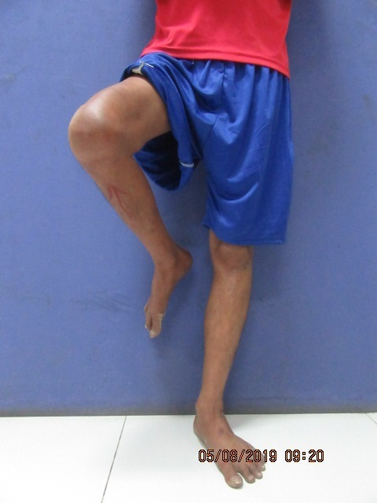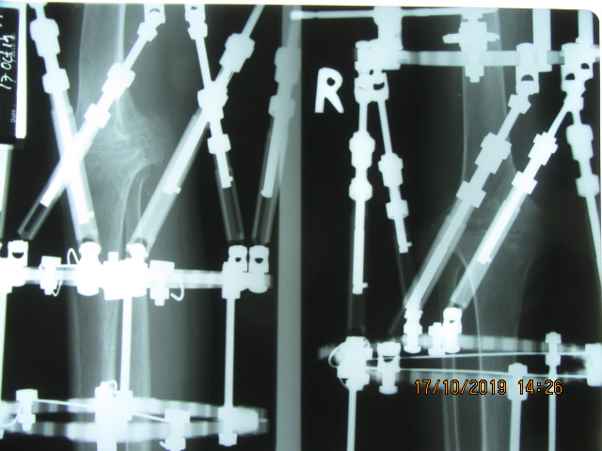

Getting used to the lack of x-ray in theatre has been a real challenge, its not that they don’t have it just that it is culturally not used – if you can visualise the bone you are fixing and the reduction looks right it probably is. Most of the time it is the cases are acceptable on the post op x-ray. Very few of the fixations are done with image intensifier and only occasionally did we have to revise something the next day.

The work here is brilliant, very cerebrally stimulating, technically challenging and the staff here are great. What is particularly unusual about the CSC is the technical ability of the scrub staff and the diligence of the ward nurses. It allows visiting teams to do really quite complex procedures (such as free fibula grafts to the maxilla and radius, huge facial tumours, I even did a femoral osseointegration for a patient with an above knee amputation from a historic landmine injury under the supervision of visiting surgeon Mr Aditya Khemka) without too much concern about the patient suddenly dying in the night.

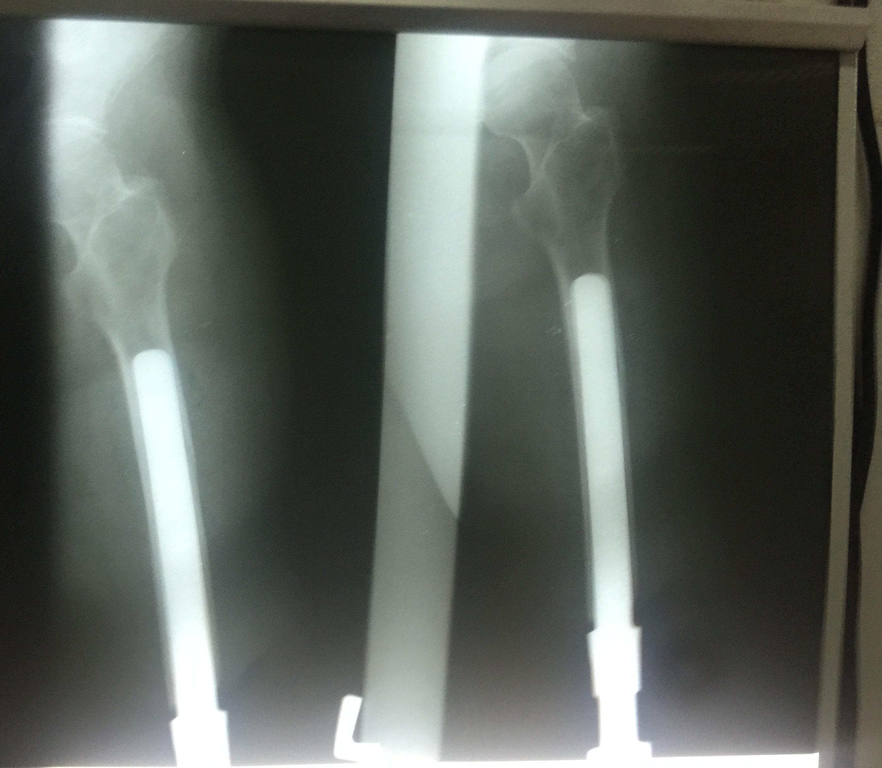

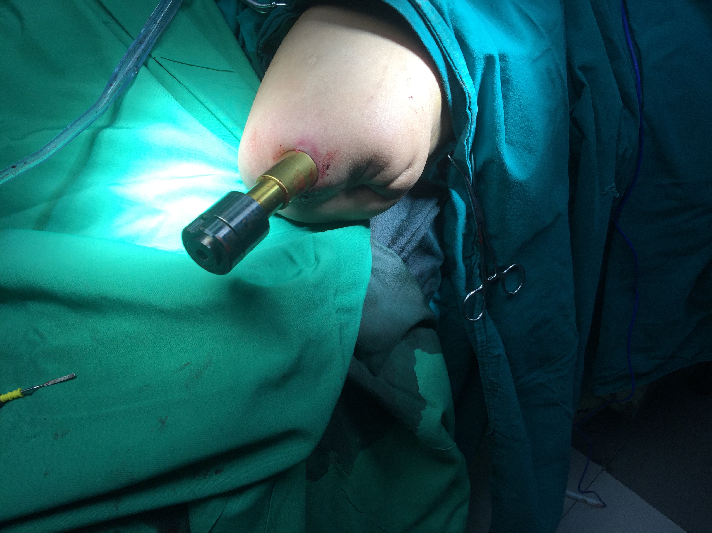

I have also known the lows of having to deal with your own complications – one of my first cases ended up with gross skin loss between the lateral incision and the traumatic medical scar over his tibia – looked like a fairly normal distance between fasciotomy lines but it sloughed off, I had to liaise with our plastic surgeons and assist with multiple flaps; we finally got coverage but I will be watching eagerly for union.

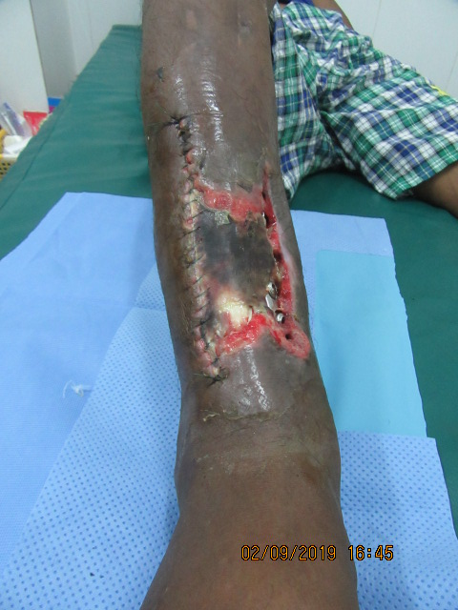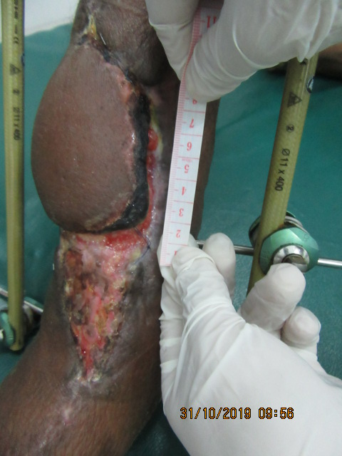

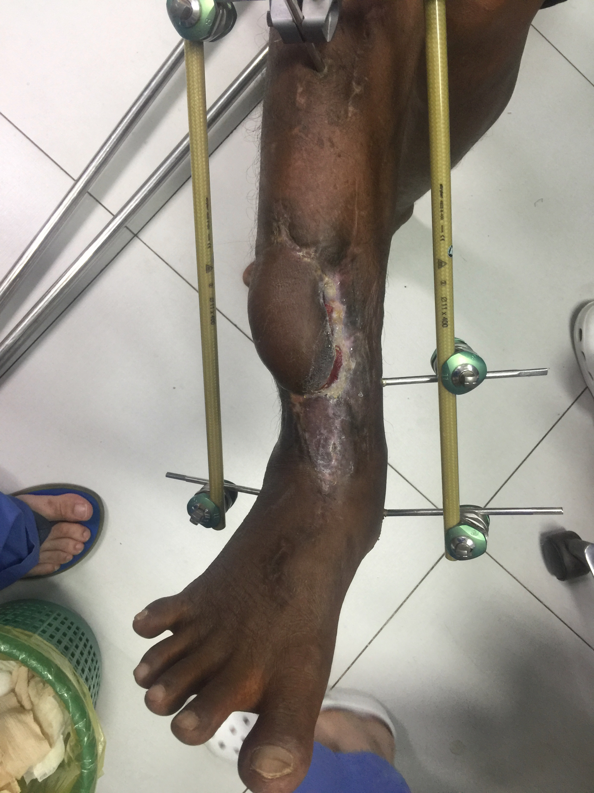

My advice for working in a placement like this is to utilise your existing trainer network, I got a great instructional document from Liverpool for frame correction of club foot which really helped in a couple of tricky cases.

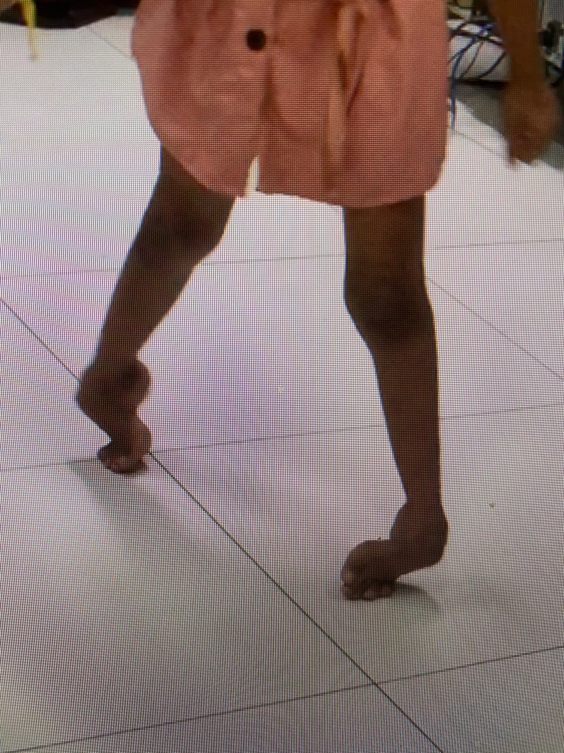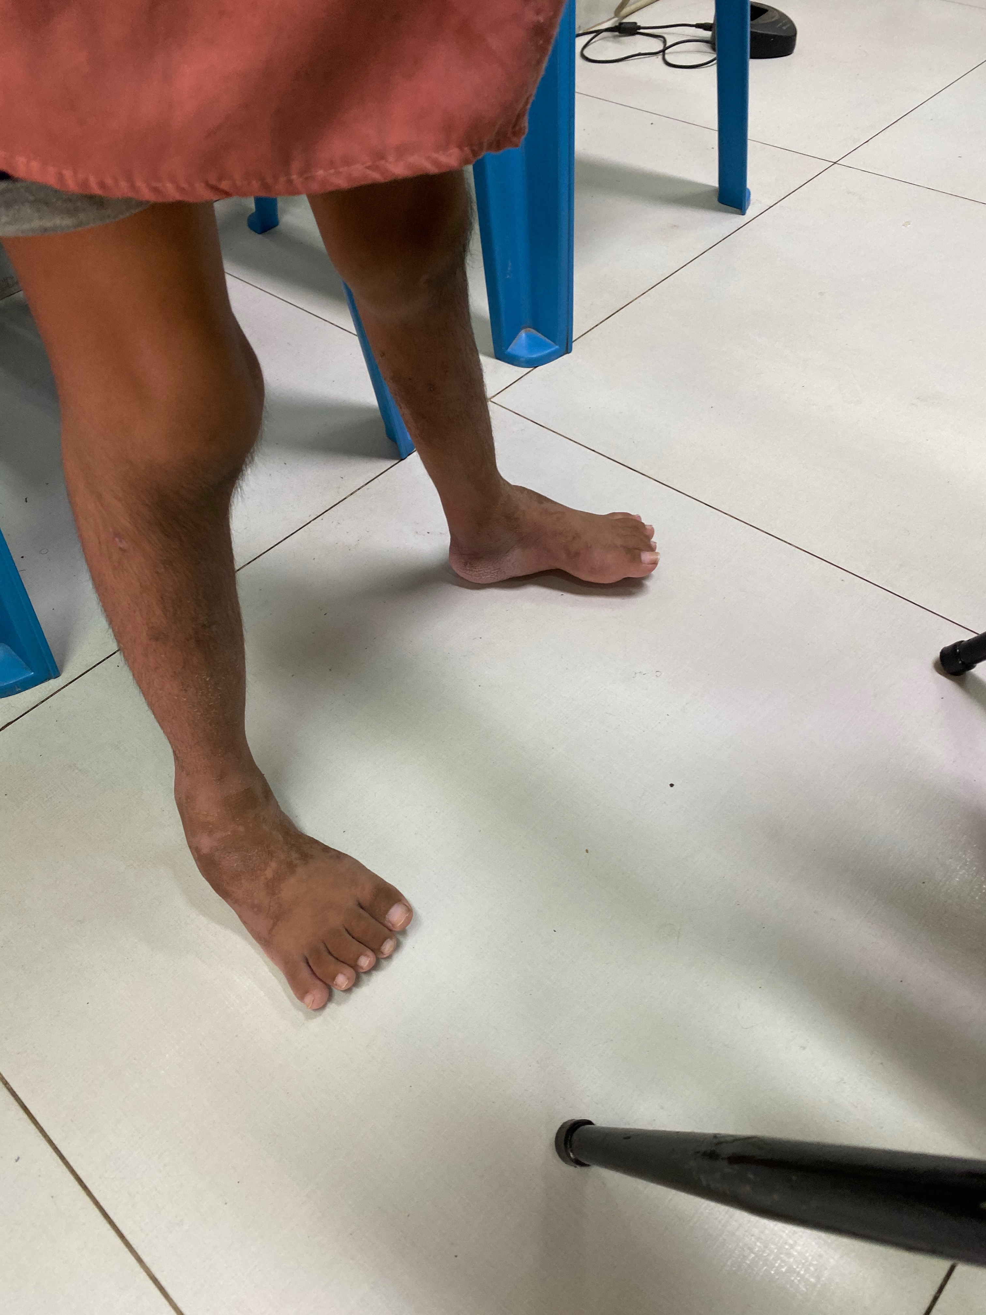

If you can make contact with a consultant who has been to the site you are going to be working (Like Mr Monsell for us) with they will be an amazing resource especially as they often know what is realistically achievable in the environment you are working in.

We got amazing clinical experience at CSC but we were keen to put back into the local skills set and ensure this was a knowledge exchange. Jim put us to task early on developing an orthopaedic curriculum for CSC. Sara or I gave a lecture most morning as per the curriculum, we used the UK curriculum as a frame work and adapted it to the needs of the hospital, working hard to give a comprehensive outline of orthopaedics. We provided a voice recording of all our lectures for use as a continuing educational resource when we are gone.

We also ran some basic fracture management courses using plumbing pipe, an angle grinder and a small fragment kit for each set of residents, which we all thoroughly enjoyed!

Was it worth uprooting the family for? Absolutely - if we didn’t have to come home to CCT we would have probably stayed, this was hands down the most rewarding clinical experience of my life and at this stage of my career I feel I was able to give back as much as I took away from the placement.

My heartfelt thanks to the British Orthopaedic Association without whose funding I would not have had the confidence to move my family half way around the world. This grant enabled us to travel to the CSC and leave the hospital in a better way than we found it. We hope that the educational and technical skills we taught will continue to benefit Cambodia for good.

